WILLIAM H. HANNON LIBRARY
First Year Seminar Information Literacy Tutorial

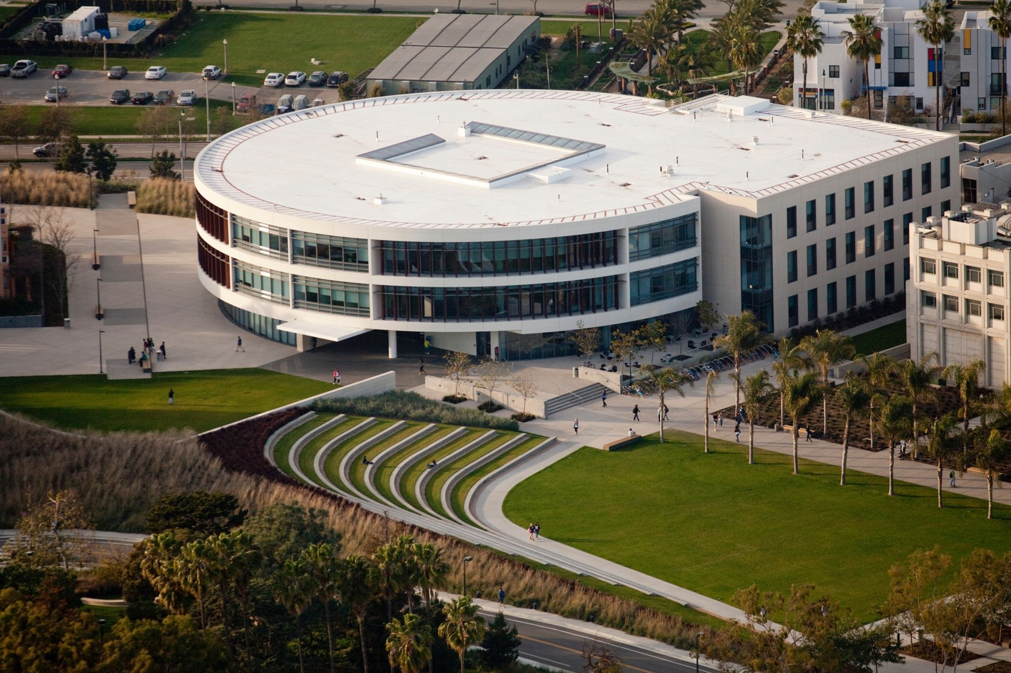
2023-24
Faculty User’s Manual

Table of Contents
FYS Information Literacy Tutorials 1
TUTORIAL CONTENT 1
Tutorial Content Overview 1
Point Values 1
Learning Outcomes 2
Key Points 2
Detailed Content Outline 3
USING THE TUTORIAL IN BRIGHTSPACE 6
Locating the Tutorial in Brightspace 6
Preparing Your Course Site 6
Default Settings and Customizations 6
USING THE GRADES FEATURE IN BRIGHTSPACE 9
Reading Grades 9
Modifying Grades 10
Manually Entering Grades 12
Export Grades to Excel 13
TROUBLESHOOTING TECHNOLOGY 14
Technology Requirements 14
Technology Troubleshooting 14
INCORPORATING THE TUTORIAL INTO COURSE CONTENT 17
Sample Syllabus Text 17
Discussion Topics 18
Sample Assignments 20
APPENDIX A – KEY POINTS 21
APPENDIX B – ASSIGNMENTS 25
CONTACT INFORMATION 31

LION’S GUIDE TO RESEARCH & THE LIBRARY
F
irst Year Seminar (FFYS) courses are required to “assign at least 10% of the course grade on the basis of assessed information literacy, which must include completion of standardized tutorials prepared by LMU librarians” (https://perma.cc/JEU6-Y9B9). This document has been created for FFYS
faculty as a guide to using the tutorial.

TUTORIALCONTENT
This section will cover the following items:

Tutorial Content Overview

Point Values

Learning Outcomes

Key Points

Detailed Content Outline

Tutorial Content Overview
The FYS library modules are a collection of 4 online learning objects. The tutorials are as follows:

Module 1: STARTING YOUR ASSIGNMENT Module 2: TYPES OF INFORMATION Module 3: FINDING BOOKS
Module 4: FINDING ARTICLES

L I O N ’ S G U I D E T O R E S E A R C H &
T H E L I B R A R Y I S
W O R T H A T O T A L O F 1 2 0 P O I N T S

Point Values
In total, the tutorial is worth 120 points. The point breakdown for each tutorial is as follows:
Module 1: Starting Your Assignment Tutorial: 30 pts Module 2: Types of Information Tutorial: 30 pts Module 3: Finding Books Tutorial: 30 pts
Module 4: Finding Articles Tutorial: 30 pts

1

Learning Outcomes
Each section of the tutorial has a specific set of learning outcomes. They are as follows:

Tutorial 1: STARTING YOUR ASSIGNMENT
Upon completing this tutorial, student will be able to:
- Understand that scholarly research is a conversation among scholars and experts.
- Select a balanced research topic.
- Identify key concepts and keywords in your research topic.
- Find and use credible background information.
Tutorial 2: TYPES OF INFORMATION
Upon completing this tutorial, student will be able to:
- Identify the appropriate type of information based on your information need.
- Understand how information is produced.
- Differentiate between primary, secondary & tertiary sources.
- Understand the difference between scholarly, popular, and trade information sources.

Tutorial 3: FINDING BOOKS
Upon completing this tutorial, student will be able to:
- Identify key places to search for books.
- Understand the organization of books in the library in order to locate a book in the library.
- Construct an appropriate search strategy in the library catalog.
- Identify book citation styles

Tutorial 4: Finding Articles
Upon completing this tutorial, student will be able to:
- Identify key places to search for articles.
- Understand how to read an article record in a research database in order to predict its usefulness.
- Construct an appropriate search strategy in a research database to find articles.
- Identify journal article citation styles

Key Points
Each tutorial has a link to a collection of “Key Points” that students may print out. The key points summarize major learning concepts from each module and can be found online:

Starting Your Assignment: https://lmu.box.com/v/module1keypoints Types of Information: https://lmu.box.com/v/module2keypoints

Finding Books: https://lmu.box.com/v/keypointsmodule3 Finding Articles: https://lmu.box.com/v/module4keypoints

Detailed Content Outline

Section A: Starting Your Research Assignment
Topics: introduction to college-level research and scholarly communication; choosing a balanced topic; identifying the key concepts in a research question and compiling a list of keywords; identifying an “information need” and finding background information.

Detailed Description:
Introducing College-Level Research
This section introduces the student to the purpose and expectations of college- level research. It explains that research is a way of tapping into the scholarly communication network and shows that the scholarly resources they are asked to use in their research assignments represent the way scholars present their ideas to their peers. The concept of “audience” is also explained.

Using Background Information
This section covers identifying an “information need” and then locating and using credible background information. A short video explains the concept of finding background information and is followed by examples of subject-specific encyclopedias that can be found in the library’s resources. This section also touches on the use of Wikipedia for college-level research. The student learns about using cited works or “further reading” sections from encyclopedias to find more sources.

Choosing a Topic
This section explains how to select a well-balanced topic. The interactive text demonstrates how identifying the “who, what, where, when, why, and how” of a particular topic can help narrow down its focus. It emphasizes the importance of picking a topic that is not too broad and not too narrow and shows how a topic can be approached from multiple discipline-specific perspectives. An interactive exercise then asks the student to identify balanced and imbalanced examples of research topics.

Selecting Keywords
This section explains the importance and value of identifying the key concepts of a research question and helps students begin to understand how to create a list of keywords from which they can begin their database and library searches. It explains the concept of “natural language” and shows the differences in results when using key phrases or whole sentence structure in a search engine. An exercise then asks the student to select the key concepts from sample research questions and then demonstrates how to narrow or broaden these key concepts. Following this, the importance of synonyms in research is explained and reinforced through several interactive exercises.

Section B: Types of Information
Topics: information types; how information is produced and the timeline of information production; what makes information “scholarly”; scholarly, popular, and trade sources; peer review process; primary, secondary, and tertiary sources.

Detailed Description:
Types of Information
This section introduces students to the common types of information resources available to them, including news, entertainment/popular, scholarly, opinion, and professional/trade. Information types are not inherently good or bad, but their utility will depend on your information need (e.g. timeliness or degree of research needed). For example, the tutorial demonstrates how a researcher looking for information on a very current event would use a news source rather than a scholarly source.
Blogs, tweets, and other social media are mentioned briefly as well.

What Makes Information “Scholarly”? (Scholarly, Popular, and Trade Sources)
This section introduces the differences between scholarly, popular, and trade publications by showing example publications from several disciplines. It discusses what is featured in each type of publication, who writes the content, who reads the publications, and what the content looks like. It then discusses the advantages and disadvantages of each type of publication. The student is then asked to determine the type of publication for some example articles (a citation and abstract are provided.)

Peer Review Process
The process of peer review is introduced in this section. In an interactive exercise, the student is asked to put the steps of the peer review process in order.

Primary, Secondary, and Tertiary Sources
This section defines primary, secondary, and tertiary sources. For each type of source, a multidisciplinary definition, a list of characteristics and a list of examples are given. In an interactive exercise, the student is given an example research question and a list of sources and must decide whether each source is primary, secondary, or tertiary.

Section C: Finding Books
Topics: where to look for books; introduction to the library website; using the library catalog to search for books owned by LMU; introduction to the Library of Congress Classification System; finding the physical location of a book in the library.

Detailed Description:
Where to Look for Books

This section introduces students to the search tools available to them to find books for their research assignments. It explains the difference between finding a book through the library versus finding a book through the open web.

Searching for Books in the Catalog
This section explains the student can find books owned by LMU by searching in the OneSearch catalog. It also takes the student on a
“guided search” in OneSearch. During the guided search, search strategies are introduced and important information from a catalog record is highlighted.

Finding Books in the Library
This section presents a brief description of how the books in the library are organized, with an overview of the Library of Congress Classification System. It explains how to use call numbers to get the books found in a catalog search in hand.

Understanding Citations
This section introduces citations including why we cite in scholarly work and how citations fit in to the scholarly communications cycle. It introduces the elements of common citations styles for books.

Section D: Finding Articles
Topics: where to find articles; an introduction to using the library’s website to find articles; using research databases to find scholarly journal articles.

Detailed Description:
Where to Find Articles
This section introduces students to the search tools available to them to find articles for their research assignments. It explains the difference between finding articles through the library versus finding articles through the open web.

The Library Website
This section provides an orientation to the Library website as a portal for finding articles. The Database List, Journals search box, and LibGuides are introduced and explained.

Using Research Databases
This section will take the student on a “guided search” in the Proquest Research Library research database. This database has a broad, multidisciplinary scope and a user-friendly interface. The guided search will present search strategies, show how to limit search results to “peer reviewed,” and point out other helpful features the database provides such as emailing an article and finding the full-text of an article. Finally, it will explain the common fields in an article record such as abstract and source.

Understanding Citations
This section introduces citations including why we cite in scholarly work and how citations fit in to the scholarly communications cycle. It introduces the elements of common citations styles for journal articles.

USING THE TUTORIAL IN BRIGHTSPACE
This section will cover the following items:

Locating the tutorial in Brightspace

Preparing Your Course Site

Default Settings and Customizations

Locating the Tutorial in Brightspace
The online modules that make up the tutorial are located in all FFYS course sites in Brightspace the campus’ Learning Management System. Brightspace can be accessed after logging in to “Brightspace.lmu.edu”.

The tutorial modules are loaded into each FFYS course before the semester begins. All of the modules that make up the full tutorial can be found in a section titled “Table of Contents” in each FFYS course site.

Preparing Your Course Site

S T U D E N T S W I L L N O T S E E T H E
C O U R S E S I T E W H E N T H E Y
L O G I N T O
B R I G H T S P A C E I F I T I S N O T L I V E
O R “ A V A I L A B L E ”

Before the start of the semester, the ITS Department will push out the FFYS course site templates to all FFYS faculty through Brightspace. The FFYS course site templates will have the most recent versions of the tutorial modules set up within the course under “Table of Contents”. Modules can be organized by weekly topics or sections as needed.

It is recommended that faculty use the latest course templates rather than copying an older FFYS course. This ensures that the students are using the most up-to-date tutorial modules. Using the most up-to-date tutorial modules will ensure that any technical issues can be handled accurately and timely.

Default Settings and Customizations
Default Settings
Modules:
- All of the modules are accessible to students for the entire semester.
- Students are allowed to take each tutorial an unlimited number of times. The highest grade recorded will be saved in the final grader report.

Customizations
Editing Modules:
  - Faculty can adjust the default setting to make the modules only accessible to students the week that they are due by using the “Restrictions” feature.
Instructions:
    - Navigate to the Grades page. Click the small arrow next to the module title and select “Edit Grade Item” from the menu.
    - Under the “Restrictions” tab, select the “Grade item is visible for a specific date range” radio button. This will allow you to check both the start and end date checkboxes. Enter a start and end date for your module. Students will not be able to see the item based on this date range.

  - Faculty can also adjust which grade is recorded into the Grade Center. Default settings record the highest tutorial grade.

Using the Grades Feature in Brightspace
This section will cover:

Reading Grades

Modifying Grades

Manually Entering Grades
  - Exporting Grades to Excel

When students complete a tutorial, the grade they earned will be automatically recorded in the Brightspace course site’s grades. To find Grades, navigate to the “Grade” option and select “Enter Grades”. Additionally, students have the option of printing or saving a “Certificate of Completion” with their final score for each tutorial and giving it to the faculty member or writing instructor.

Reading Grades
In Brightspace, Grades include individual columns (4 in total) for each component of the tutorial. The “Subtotal” column for the Information Literacy Tutorial category will display the cumulative percent grade earned across all 4 tutorial components.

Modifying Grades

There may be situations where you will want to modify Grades. To make changes to the individual grades in Brightspace, you will need to switch to the “Spreadsheet View”.

Change Grade Display to Point Value
By default, Grades received on the information literacy tutorials display as percentages. If it is preferable to view the grades as point values follow the steps below:
- Navigate to the Grades section and select “Setup Wizard”. You will need to add Points as a scheme, then implement the scheme in your gradebook.

- Select “Start” in the setup wizard. In Step 1, select the “Points” radio button and select “Continue”. You can then select additional settings about the calculation of grades.

- In Step 3, you can select whether or not you would like grade calculations to consider incomplete grades a zero or not (Figure 10).

- After creating the Point grading scheme, return to the Grades > Enter Grades
> Spreadsheet View to see grade items listed with point values.

Manually Entering Grades
If a student’s grade for a tutorial is not properly recorded, faculty can manually enter the student’s grade into the Grade Center. All students that complete a section of the tutorial are prompted to print a “Certificate of Completion” at the end of each tutorial.

Check for Proof of Completion
Tutorials
Students are prompted to print out a “Certificate of Completion” when they finish the tutorials. This certificate includes the day the tutorial was completed and their grade percent. Students should present this certificate before a grade is manually entered in Grades.
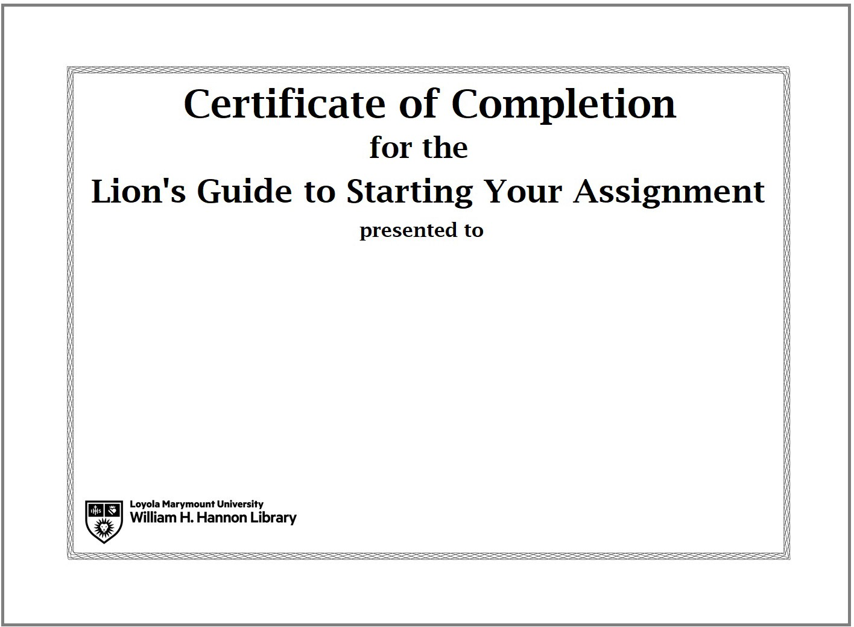

Manually Entering Grades
To manually enter a grade for a student, access the Grade section. Select “Enter Grades” and switch to “Spreadsheet View”. You can click on any number box and click “Enter” to change the grade. Be sure to save any changes. When a score has been manually entered, a small yellow arrow will appear in the corner of the cell

Troubleshooting Technology
This section will cover the following:

Technology Requirements

Technology Troubleshooting

Technology Requirements
The tutorial has the following technical requirements. Students are presented with these requirements at the start of each tutorial. The tutorial is created using Articulate Storyline software which requires:
Browser:

Required- Chrome
Network
The tutorial requires a stable Internet connection. It is recommended that they complete the tutorials using an LMU wireless or wired network.
Hardware
Students should use a desktop or laptop computer to complete the tutorial. Students cannot use tablets or smartphones to complete the tutorial. If they do attempt to use a smartphone or tablet, the tutorial will not work properly and their grade will not be recorded.

Technology Troubleshooting
Some students will run into technical issues because they have not read or understood the technical requirements.

Faculty are encouraged to contact the Instructional Design Librarian with any technical problems experienced by students or writing instructors.

The following is a list of the common issues that may confront students and how faculty can respond:

COMPLAINT: I clicked on the tutorial but nothing happened/it didn’t open!
SOLUTION:

S O M E S T U D E N T S W I L L R U N I N T O T E C H N I C A L
I S S U E S B E C A U S E T H E Y H A V E N O T R E A D O R
U N D E R S T O O D T H E T E C H N I C A L
R E Q U I R E M E N T S .

- Use Chrome Browser only

COMPLAINT: Student has a zero grade even after completing the tutorial!
SOLUTION:
- Brightspace records the highest grade for the tutorial. Contact the Instructional Design Librarian to check on the grade logs.

COMPLAINT: The tutorial froze and I couldn’t finish it! SOLUTION:
- Have the student clear their cache on their browser before attempting the tutorial again.
- If all else fails, the student can complete the tutorial on the computers in the library.

COMPLAINT: The tutorial crashed in the middle! Will that count as one attempt even though I didn’t finish?
SOLUTION:
  - The system will count an attempt only when the student has completed the entire tutorial and submitted their grade. If the tutorial crashes in the middle the student should log in again and resume from where they left off.
  - If this happens, the student should make sure they are on a stable Internet connection before resuming the tutorial.
  - The student should save the completion certificate for any issues with grade submission.

COMPLAINT: My grade wasn’t recorded in the grade book! SOLUTION:
  - Students have the ability to print out a certificate of completion for each tutorial that has their name, the date they completed the tutorials and their grade. This option is on the very last slide of each tutorial.

COMPLAINT: The tutorial said I got a question wrong, but I didn’t! SOLUTION:
  - The tutorials have been tested thoroughly and all the scoring functions work properly. If a student feels they were scored incorrectly due to a technical issue, there is detailed data available about how they answered each question in the tutorial in Brightspace. You may contact the Instructional Design Librarian for this information.

COMPLAINT: The library catalog/research database isn’t loading in the tutorial and I can’t complete the questions
SOLUTION:
  - All of the slides that include a guided search in either the library catalog or a research database have links to open the appropriate URL in a new window. Students can use this option if they find the search pages in the database or library catalog are not working properly within the tutorial itself.

COMPLAINT: The video isn’t loading in the tutorial / I can’t see it SOLUTION:
  - All of the videos have links to open the appropriate URL in a new window. Students can use this option if they find the videos are not visible within the tutorial itself.

Incorporating the tutorial into course content
This section will cover the following:

Sample Syllabus Text

Discussion Topics

Sample Assignments

Sample Syllabus Text
Please feel free to use some or all of the following language in your course syllabus:

Information Literacy
Information Literacy entails the ability to locate, evaluate, and use information effectively and ethically, developing the critical thinking skills that form the basis of lifelong learning. We will be spending some time in the course on information literacy as it relates to writing and the study of .

Information Literacy Learning Outcomes for FFYS
  - Be able to evaluate sources for quality (e.g., by learning to differentiate between scholarly and popular sources)
  - Acquire research skills including use of the library catalog and electronic databases to retrieve books or articles, whether in print or online

Information Literacy Tutorial
During the course of the term students are required to work through the library tutorials. All of the modules are accessible through Brightspace. In each section, the tutorial can be taken an unlimited number of times. If a student elects to take the tutorial twice, the highest grade will be the one counted toward the final grade. Each tutorial needs to be completed by the following due dates:

- Starting Your Research Assignment Tutorial- complete by X/X/2018 (e.g. 9/23/2018)
- Types of Information Tutorial - complete by X/X/2018 (e.g. 10/7/2018)
- Finding Books Tutorial - complete by X/X/2018 (e.g. 10/21/2018)
- Finding Articles Tutorial- complete by X/X/2018 (e.g. 11/4/2018)

The tutorials may be found through Brightspace. Just follow these steps:
  - Login to Brightpsace at brightspace.lmu.edu or mylmu > Brightspace
  - Click on the course title FFYS Course: ( ) to enter the course page.
  - Click on the “Content” header in the horizontal menu.
  - Click on the module link in the course menu under “Table of Contents” on the left-hand side of the page.

The Library has created a FFYS 1000 LibGuide to further assist students with the content and key concepts in the tutorial. It is located at http://libguides.lmu.edu/fFFYS1000

Examples Syllabi can be found on the libguide: http://libguides.lmu.edu/FFYS/syllabus - s-lg-box-15987624

Discussion Topics
To help students understand the themes in each tutorial module, consider starting a discussion using any of the following. Time the discussion to coincide with the due date of the tutorial where the theme is covered.

T H E M E :
S C H O L A R S H I P I S A C O N V E R S A T I O N

Starting Your Assignment Module
Theme: Scholarship is a Conversation
Begin by asking how students find information. Do they use Google? The library? Twitter? Then describe how you and/or your colleagues do research, emphasizing any professional organizations you are affiliated with and the type of literature you typically read. The purpose of this discussion is to articulate the scholarly process by emphasizing how scholars communicate ideas with each other.
Theme: Scholarship is a Conversation
Alternatively, have the writing instructor interview a FFYS faculty member and ask him/her to describe how they do research, how research gets disseminated in their field, etc. Students should be encouraged to ask their own questions.
Theme: Understanding the Research Process
Have students reflect upon the steps they went through when researching a major purchase or event in their lives (buying a car, selecting a college, etc.). Then identify the steps involved in the research behind such a decision, and confront the importance of employing a similar strategy in the academic setting.

T H E M E :
U N D E R S T A N D H O W
I N F O R M A T I O N I S P R O D U C E D
Theme: Find and Use Credible Background Information
Find a Wikipedia article on a topic relevant to the course and a related article in a published reference or academic database. Invite the students to compare and contrast the two. For extra credit, you can ask for volunteers to improve the Wikipedia article by using better sources.
Theme: Identify Key Concepts and Keywords in Your Research Topic
Pick a research paper topic and invite your students to help you come up with keywords.

Types of Information Module
Theme: Identifying the Appropriate Type of Information Based on Information Need
Start a discussion with your class about what the appropriate information sources are for your discipline. Does your discipline ever use popular sources for research? Why or why not.
Theme: Understanding How Information is Produced
Discuss your experience with being published in an academic press or peer reviewed journal. What challenges did you face? What value did the process add?
Theme: Different Information Types
Compare the same topic across multiple source types (scholarly, popular, etc.) in order to emphasize the different ways information is presented.
Theme: Understanding How Information is Produced
Brainstorm author characteristics that indicate trustworthiness on a particular topic as a large group, collaborating to generate characteristics posted and shared with all students.
Theme: Types of Info Module
Have students look at a blog, a video on YouTube, a collection of tweets, or some other type of social media regarding a contemporary event (e.g. the demonstrations in Ferguson, MO). Ask them questions about the creators of the item. How trustworthy is the author? Is the item part of the mainstream media or not? If not, how does it differ? What value does this item have to scholars?
Theme: Primary Sources
Have students visit the Archives and Special Collections Department to experience a primary source first hand. For more info, please see the library site: http://library.lmu.edu/generalinformation/departments/archivesandspecialcol lections/

Finding Books Module
Theme: Finding Books Module
Do you use books? Start a discussion on the relevance of books to your discipline, and then have students find a book related to a class topic.

Theme: Understanding Citations

Have students include citations in forum or paper assignments.

Finding Articles Module
Theme: Construct an Appropriate Search Strategy in a Research Database to Find Articles Discuss with your class the things you look for in an article abstract. Are there key phrases that might be useful for research for your course?
Theme: All of Finding Articles Module
Have students find an article related to a class topic.

Theme: Understanding Citations
Have students include citations in forum or paper assignments.

Sample Assignments
The following is a list of assignments that correlate to the various themes of the information literacy tutorial. All detailed assignment prompts can be found in Appendix B.

Please note: These sample assignments are here for you to copy as is or modify as needed. If you would like clarification on any assignment, please feel free to contact the Reference & Instruction Department at refdesk [at] lmu.edu.

Starting Your Assignment
- Topic Development/Pre-Search Worksheet
  - Find online @ https://lmu.box.com/topicdev

Types of Information
- Authority is Contextual and Constructed: Class Discussion of Authorship
- Object Analysis
- History of the Book

Finding Books
- Finding Books Exercise

Finding Articles
- Finding Articles Exercise
- Selecting a Database for Your Research

There are additional assignment ideas available in CORA, the Community of Online Research Assignments: www.projectcora.org

19

Appendix A– Key Points
Key Points from “Starting Your Assignment” Module
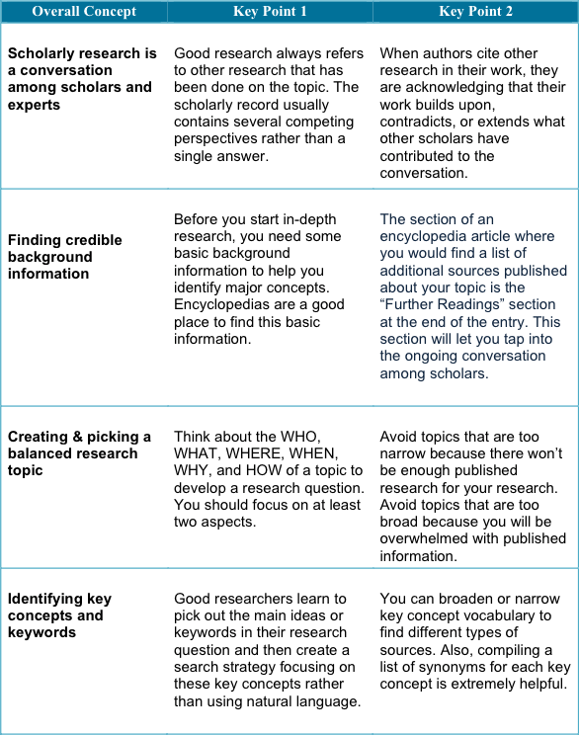

Key Points from “Types of Information” Module
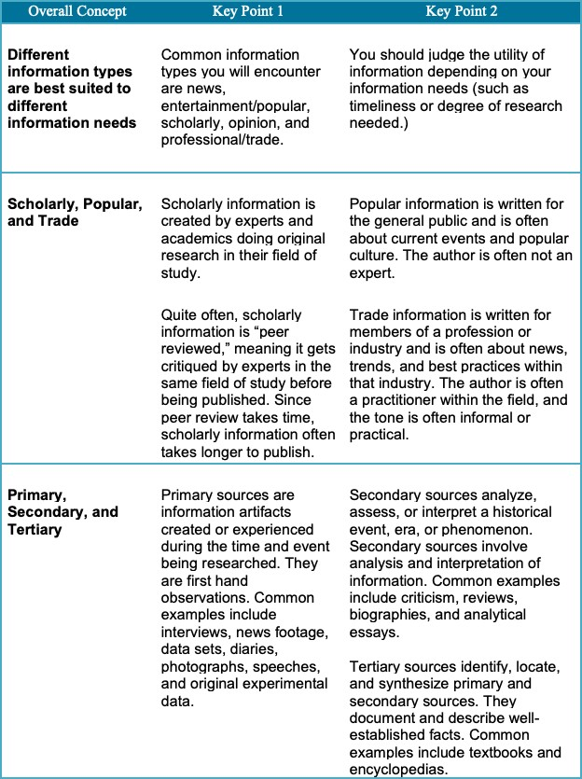

Key Points from “Finding Books” Module
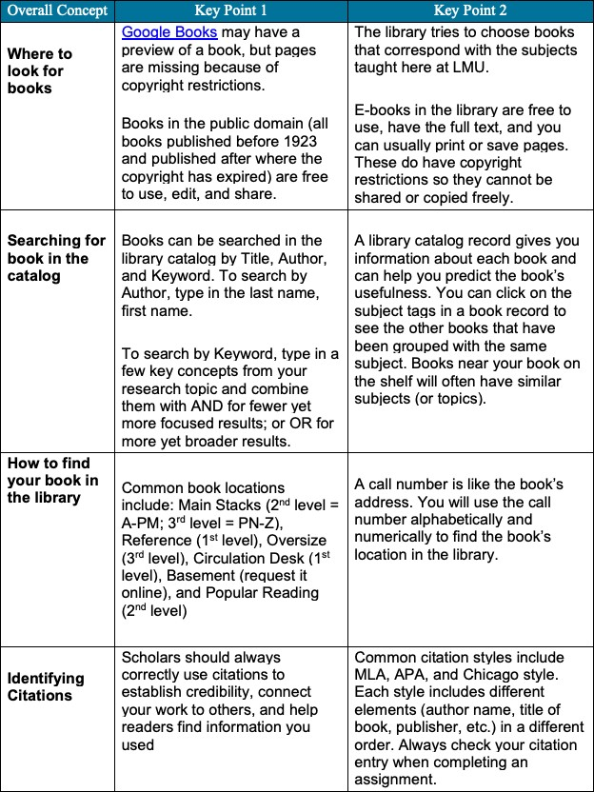

Key Points from “Finding Articles” Module
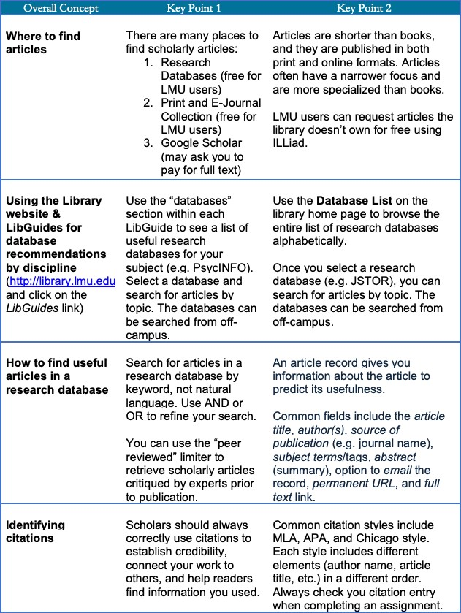

Appendix B– Assignments

Starting Your Assignment - Topic Development Worksheet
This worksheet can be found online at: https://lmu.box.com/topicdev

Types of Information - Authority is Contextual and Constructed: Class Discussion of Authorship
The following activity is meant to demonstrate the concepts of authorship and authority to your students. It introduces the idea that context can influence the tone and writing style of a faculty member or scholar and also introduces the concept of the scholarly conversation. At the end of this activity, students should…
- Be able to compare and contrast two different sources in order to comprehend the different types of context for scholarly ideas.
- Recognize scholarly blogs and other informal scholarly communication sources in order to describe scholarly communication as an ongoing and evolving dialogue.

Activity
Present your class with excerpts from two different information types on the same topic and written by the same author. For example, you can use a blog post and a peer reviewed article or a YouTube video and a scholarly book. You can even use your own work, by using a conference poster and an article or a book and an email—the point is to find two dissimilar sources. You will present the two sources to the students without revealing the author and engage the students in a discussion regarding authority.

Example:
The following example uses excerpts from a blog post and an essay published in a peer- reviewed journal, on food insecurity and fast food companies, written by Dr. Marion Nestle. Dr. Nestle is the Paulette Goddard Professor in the Department of Nutrition, Food Studies and Public Health at New York University and is also the author of the popular blog “Food Politics”.

Article 1 is a blog post from Food Politics: M Nestle. (2013, Oct 16). Today is World Food Day: Perspectives. Retrieved from http://www.foodpolitics.com/2013/10/today-is-world-food-day- perspectives/

Article 2 is a journal essay by Nestle: Stucker, D., & Nestle, M. (2012). Big Food, Food Systems and Global Health. PLOS Medicine, 9:6, 1-4. DOI: 10.1371/journal.pmed.1001242.

After giving your students a chance to read the two articles, engage them in a discussion regarding the authority of each piece.

Potential Discussion Questions:
- Which article do you trust more? Why?
- Answers can include the following:
- Language: Article 1 uses natural language, article 2 uses scholarly terms
- Tone: Article 1 is conversational, 2 is formal
- Citations: Article 2 clearly shows evidence of citation
- How would you use each article?
- Example: Use article 1 to stay up to date on the subject, use 2 for a research paper in college
- Which one did a scholar/faculty member write?

After a few minutes discussing, reveal the authorship of both articles. Then ask the class for their observations/revelations.
- What is the purpose of academic blogs?
- What are the advantages and disadvantages of both mediums?
Students will also find it useful if you discuss how you use blogs or other forms of social media in your research (that is, if you do). Discuss how you stay aware of changes in your field and how you approach research. The point is to get students to comprehend scholarly communication as a dialogue between peers and that the work of an “authority” can take many different forms.

Types of Information - Object Analysis
A “First Steps” In-Class Exercise
The following questions are designed to introduce the idea of “archaeological” analysis of a primary source. This is the first encounter between you and a cultural object. It is not as important to find the “right” answer as it is to start formulating key questions that may allow you to “step back in time” and understand why this object exists; what cultural purpose it may have had.
Choose one object (book or other artifact), and jot down notes answering the following questions for discussion. IMPORTANT: please do not use any secondary source to help you understand your object. You are the sole creator of this first step toward understanding – and you are also the investigator who begins to establish what you do not know.
- What is your selected object? What material is it made of? Can you tell when it was made? (If so, how? If not, what would help you?)
- For whom do you think this item was made? What might its purpose have been?
- What is one thing about the object that you find interesting?
- What else might you want to learn about it if you were to research it further?

Types of Information – History of the Book
History of the Book: Early Printed Texts an In-Class Exercise
The following questions are based on foundational elements of “archaeological” analysis conducted by researchers of manuscripts and early printed books. By analyzing their physical aspects, book artifacts tell us about their early readers and what cultural purpose they may have had. The physical object’s own story is as important as any text that was written or printed in it.
Please use the artifacts at your designated station to answer the questions below. There may be more than one “right” answer so use this opportunity to explore the display and ask questions of the artifact!

- Which item at your table is an incunabulum? (Identify by title). Why is it an incunabulum?
- Which early printed book at your table contains spaces left for manuscript initials? (Identify by title and date). Are the spaces blank? If not, what do you see there?
- Identify a book (by title and date) that has signatures. Write down a signature that you see on a signed leaf.
- Identify a book (by title and date) that has catchwords. Write down a catchword that you see on a page. Does that particular leaf also have a signature? Is your catchword on the recto (front side) or verso (back side) of the leaf?

Finding Books – Finding Books Worksheet

How are the books organized in the library and where do you find them?
Go to http://libguides.lmu.edu/FFFYS1000 and click on the Books tab. Look in the “Find books at LMU” box and use the OneSearch (library’s online catalog) keyword search box to find the best book on your topic that is owned by the LMU Library. In the space provided, write down the book information from the library catalog record.

Finding a book owned by the library

Location
Call Number
*What floor?

*Using the Book directory box (http://libguides.lmu.edu/FFFYS1000 under the
Books tab), on what floor would you find your book?

Citing your book

Author(s) or Editor
Title
Location
(city)
Publisher
Year
Medium
(print or web)

Evaluate whether or not this book meets your needs. Is it useful for your research?
Does this book meet your needs? Who is the author? What is the purpose of the book (e.g. news? entertainment? academic? opinion?)? Please explain.

Finding Articles – Finding Articles Worksheet

How are articles organized and where do you find them?
Go to http://libguides.lmu.edu/FFFYS1000 and click on the Databases tab. Look in the “General Research Databases” box and click on “Academic Search Complete.” Search Academic Search Complete to find the best article on your topic. In the space provided, write down the article information from the Academic Search Complete record.

Article:
Author(s)
Article Title
Source (Publication
Name)
Volume
Issue
Date
Page #
Database

Medium
(print or web)
Date accessed

Evaluate whether or not this article meets your needs. Is it useful for your research?
Does this article meet your needs? Who is the author? What is the purpose of the article (e.g. news? entertainment? academic? opinion?)? Please explain.

Finding Articles – How to Select a Database for Your Research
Introduction
Research databases allow users to search for a variety of materials at once, such as scholarly journal articles, popular culture articles, newspapers, and book reviews. Databases may be general or cover a specific topic, for example, business, theology, or visual arts.
Finding Databases
Go to LMU’s LibGuides webpage (http://libguides.lmu.edu) and click on the “Go to A-Z List” link to see the Databases List.

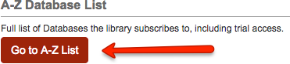

Explore
Browse by subject and select the subject your research topic generally falls under. For example, if your topic is Microsoft, select “Business.”
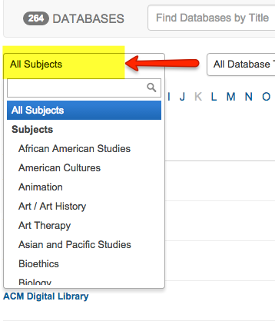

Find Relevant Databases for Your Research Topic
Think about your research topic and the type of sources you need. Read the descriptions of the databases to choose the best ones.
Example: Business Source Complete and ABI/INFORM provide business sources such as company information, industry profiles, business news, etc.
- What is your research topic? What type of sources will you need?

List three databases relevant to your research topic. Then analyze each database:
  - Does the database provide subject-specific resources? Is there a more focused database?
  - What type of sources can you find in the database?
  - Does this database allow you to limit your search by date and source type?
  - Is this database effective and useful for your research? Why?

Database 1: | Notes:
Database 2: | Notes:
Database 3: | Notes:

Example Research Topic
1. What is the relationship between cell phone use and traffic accidents? What are the implications for banning cell phone use while driving? Sources: news articles, scholarly journal articles, reports

 | Notes: Contains over 700 journals on communication
 | and mass media. Yes, this database is subject -specific.
Database: | This database provides academic journal articles (I can
Communication & | limit by peer-reviewed articles*), trade publications, and
Mass Media | magazine articles. Yes, I can limit my search by date and
Complete | source type. Yes, this database was useful because I found
 | very specific articles on my topic. Yet, I only retrieved 3-5
 | articles.

29

*Peer-reviewed articles: Many databases allow you to limit your search by this source type. Peer-review is the process by which an author’s peers, recognized researchers in the field, read and evaluate a paper (article) and recommend whether the paper should be published, revised, or rejected.

Contact Information
Darlene Aguilar
Instructional Design Librarian William H. Hannon Library darlene.aguilar@lmu.edu

30

